**Introduction**

For assignment 1 I was tasked with creating a convolutional neural network for CIFAR-100. In my project I created a multi-layer convolutional neural network inspired by the VGG-16 architecture.

**Method**

My method was inspired by the VGG-16 architecture, although I did not directly implement the architecture in my project. The VGG-16 architecture is meant for high resolution images and very large datasets, for this reason I did not use a full VGG-16 architecture for my project. I instead decided to adapt the VGG-16 architecture to have less complexity to adapt for the CIFAR-100 dataset. I did this by having 1 convolution layer in the first block instead of 2, removing the 4th convolution block, and adjusting the neural node network to be 128x128x100.

**Experiment**

I experimented with an adaptation of the VGG-16 architecture using Google Colab where I implemented the CNN. In the experiment I used keras, numpy, and mathplotlib to test and get data for the experiment. In my experiment I used a batch size of 64 and 20 epochs to adequately test the architecture in a timely manner.

**Analysis**

The custom VGG-16 architecture performed well during the training set, slowly gaining in accuracy and losing loss value each epoch. The adapted architecture did not however perform that well with the test values, as it slowly gained accuracy and lost loss value until it stalled at around 50% accuracy. One positive note about the architecture was how it was able to get a high accuracy on the training sets, while a negative note on the architecture was how slow the architecture was to train.

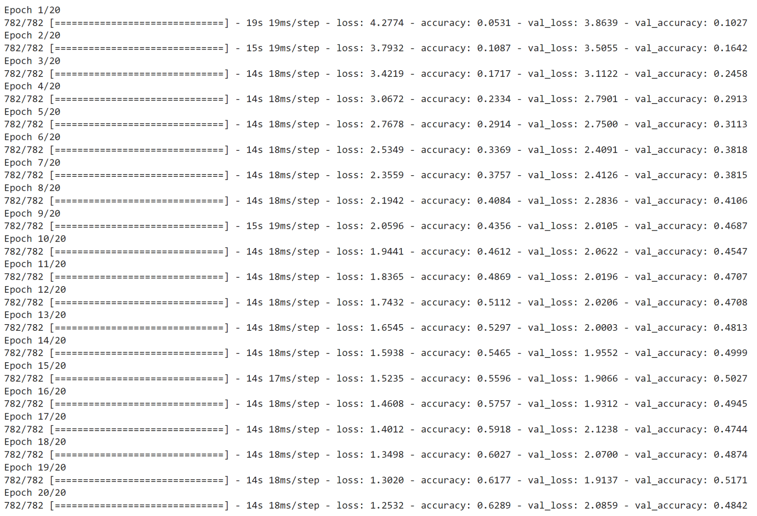

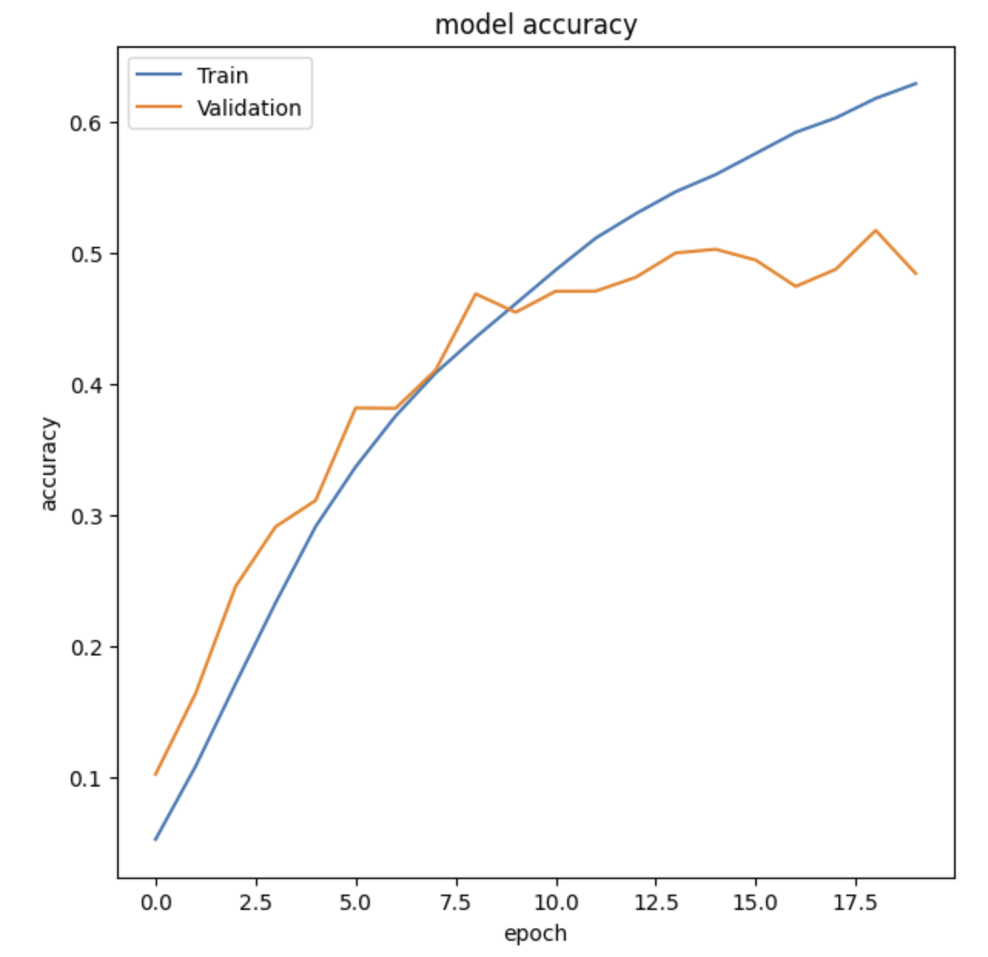

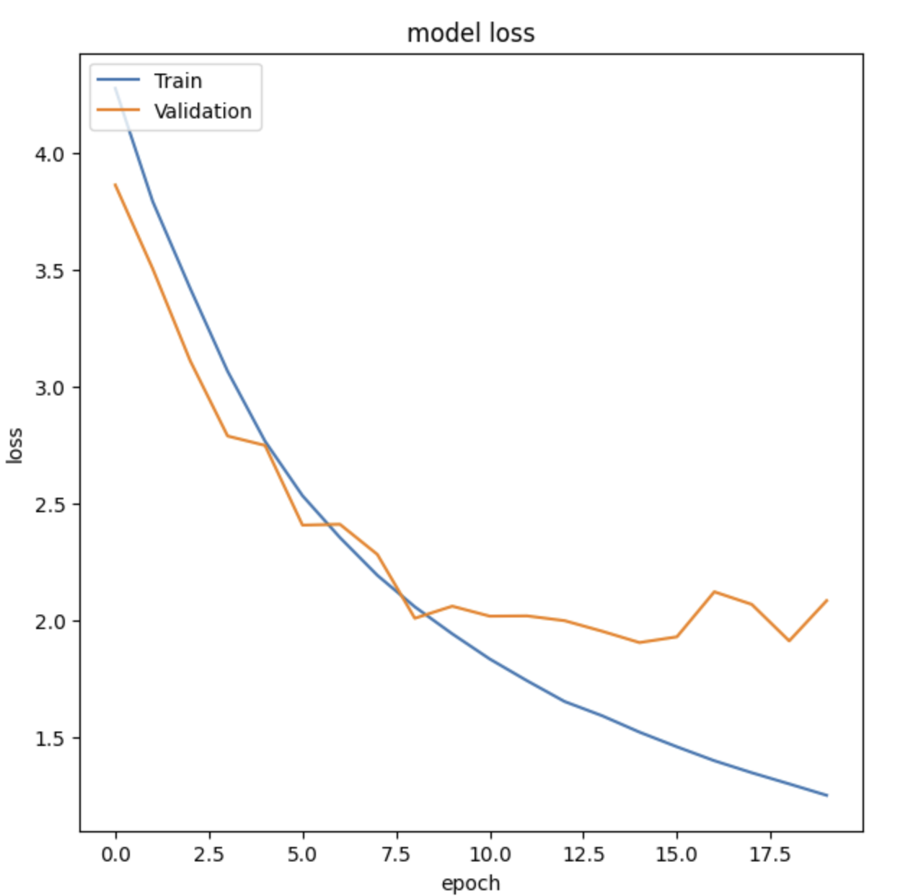

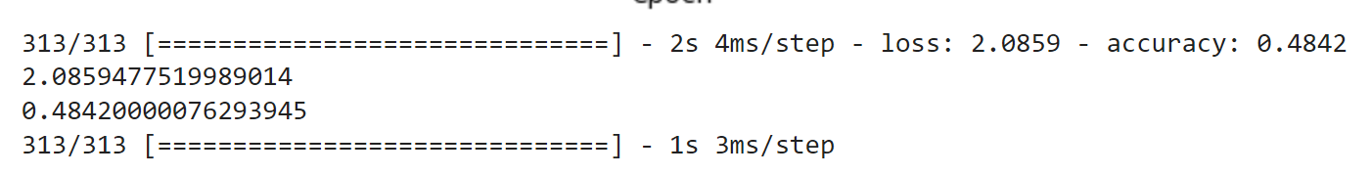

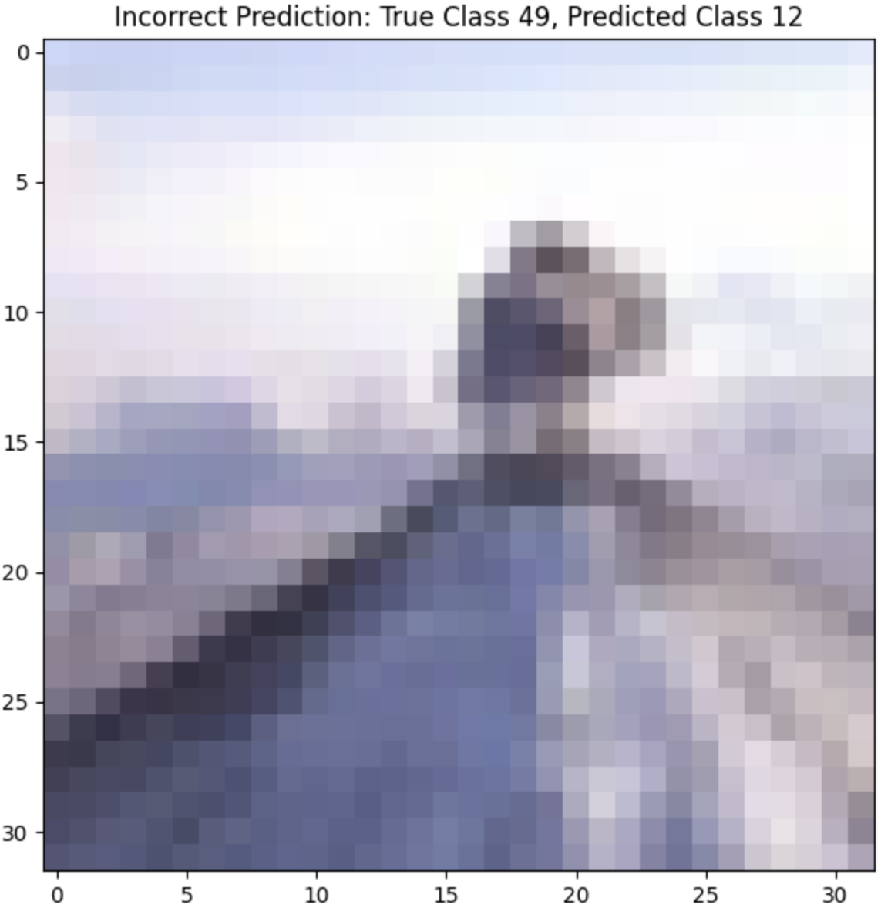

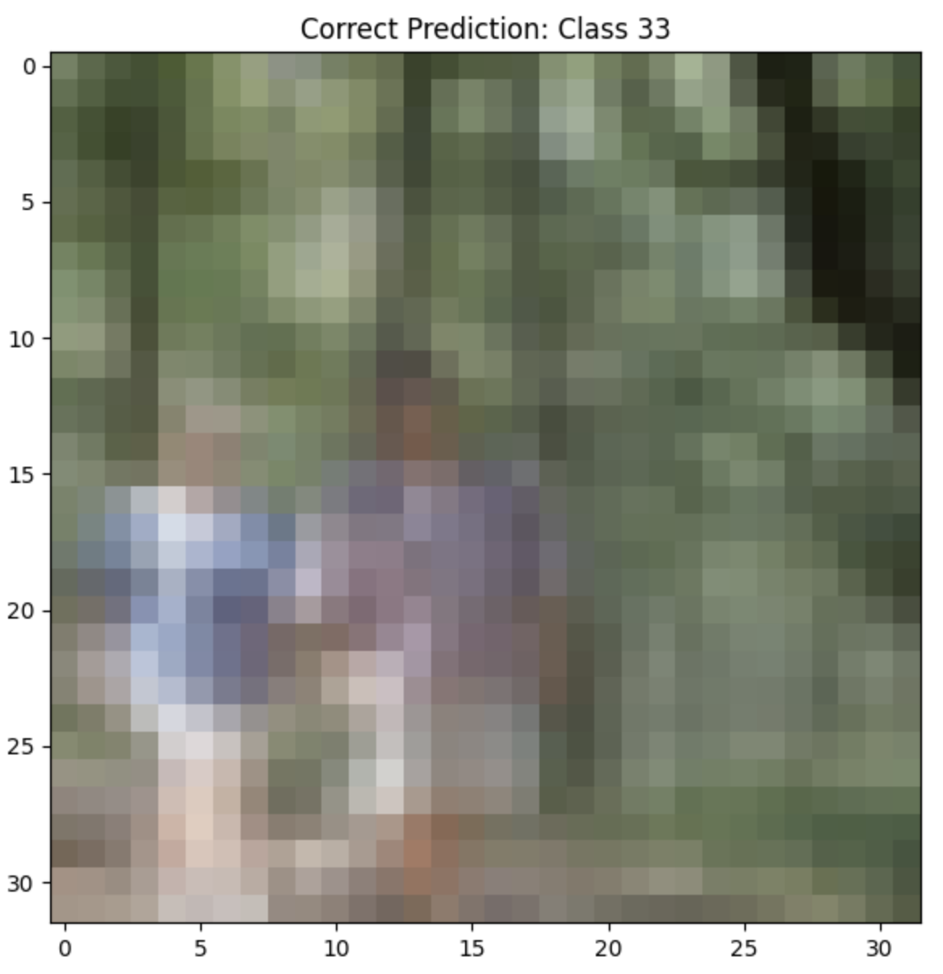

**Conclusion**

In conclusion the CNN I made with an adaptation of the VGG-16 architecture did not perform exceptionally, although it taught me the methods to make a capable CNN. The adapted architecture performed well in training sets, although it lacked in performance when it came to test sets. This architecture would be fine to identify images seen before, although it would be inadequate to identify new images.